ASSIGNMENT N0. 15

Using Subquerries with DML Command

Q.1. Assume there is a table called Multicust with all of the same columndefination as Salespeople. Write a command that inserts all salespeople with more than one customer into this table.
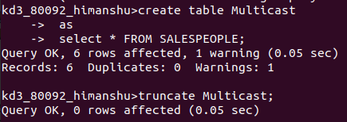

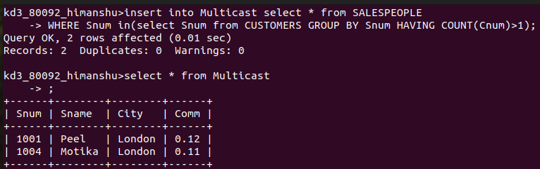

Q.2. Write a command that delets all the customers with no current orders.

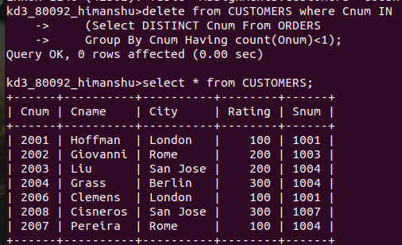

Q.3. Write a command that increase by 20% the commission of all salesperson with total orders above Rs.3000.

